**Steps to create a master page in ASP.NET**

**Step-1**

**Create an empty project**

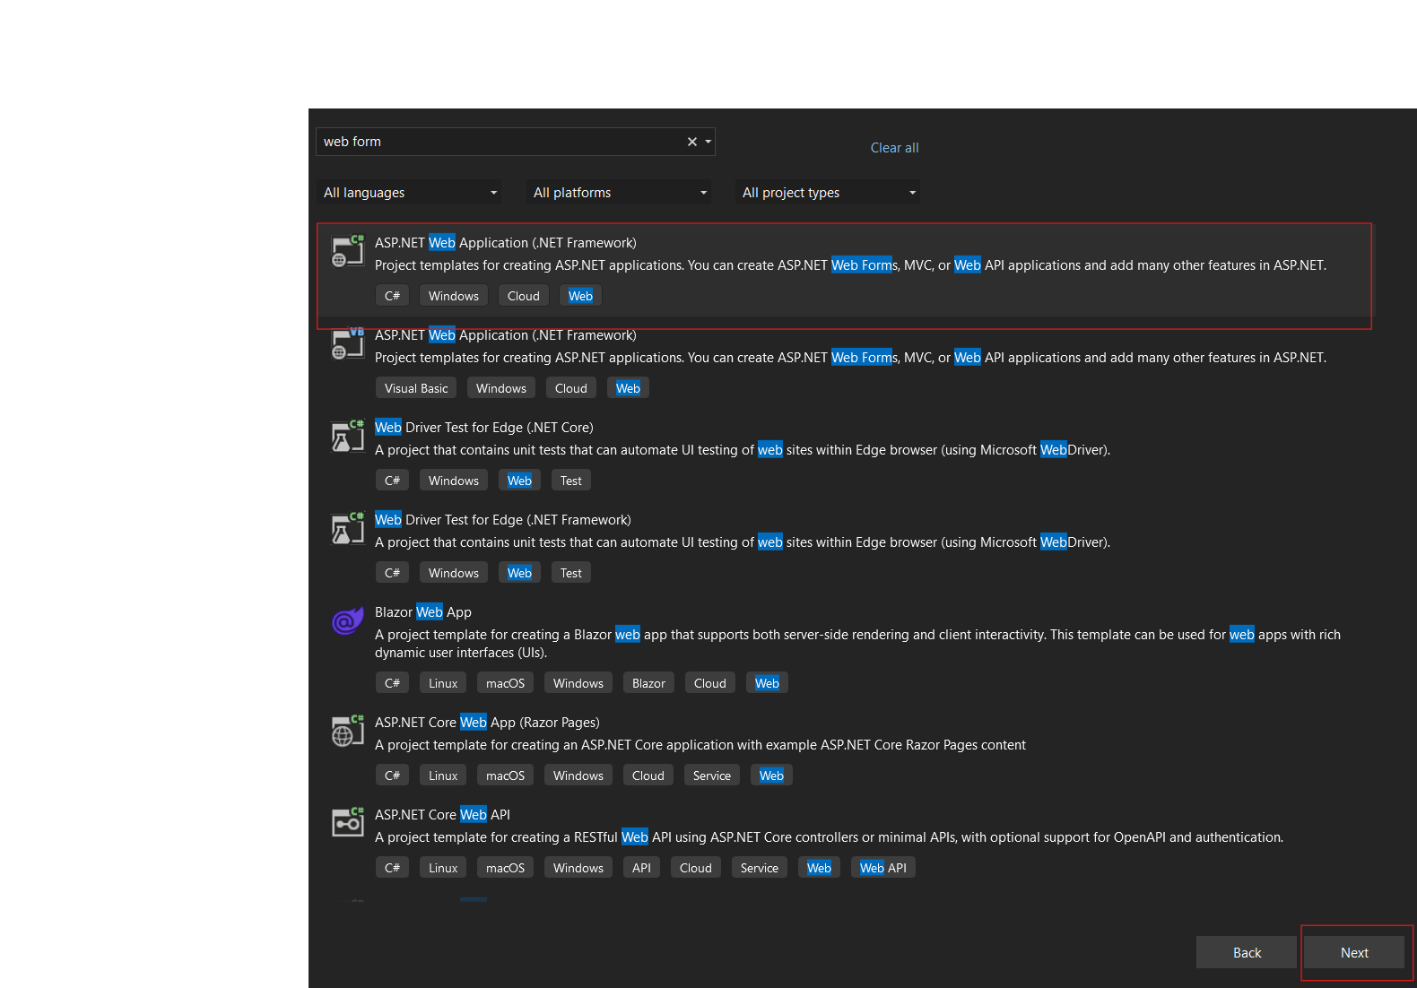

**Step-2**

**Add a master page**

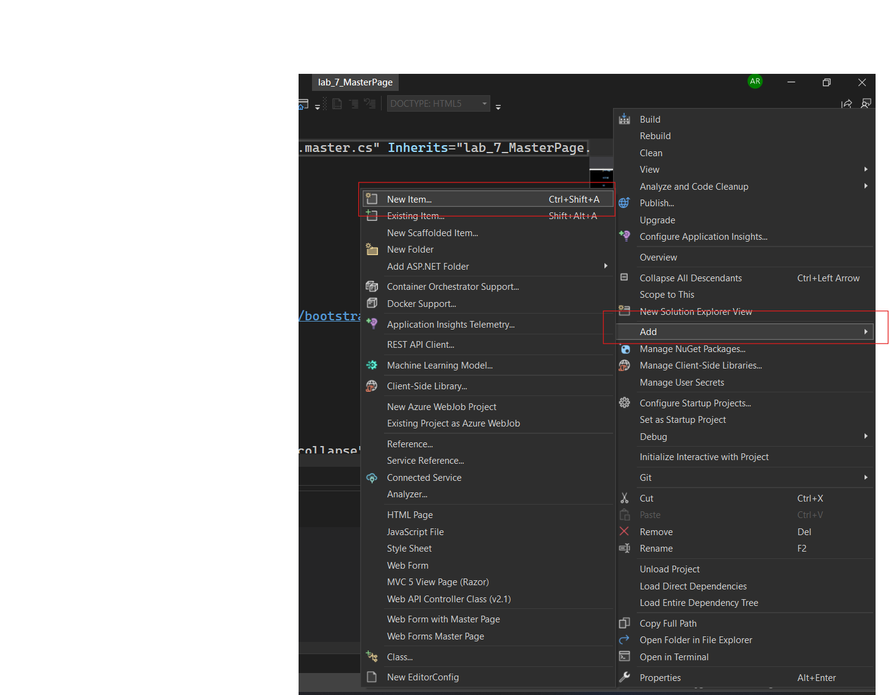

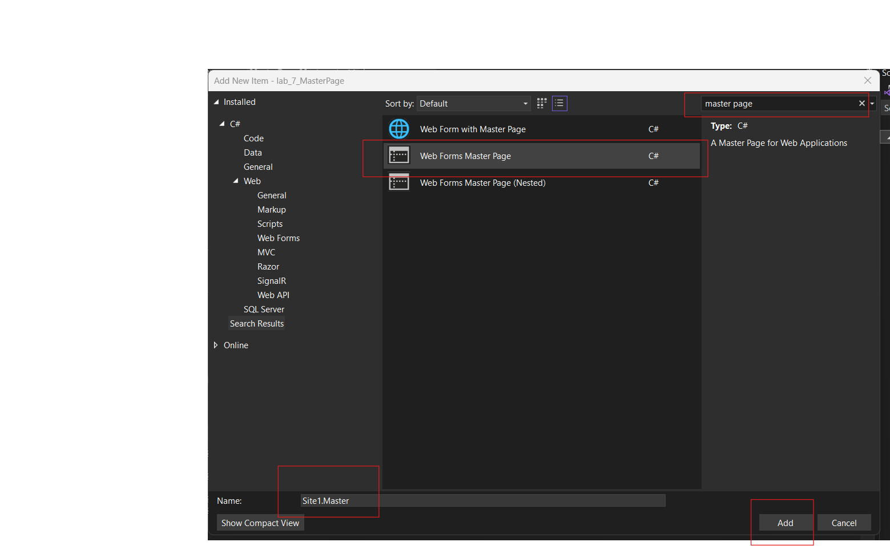

**Step-4**

**Add Navbar and Footer As per image also add CDN in header file or your style**

**Step-5**

**Create ASPX pages**

**Step-6**

**Add your home page content and the first red box Content1 is section where you add your style and etc.. mean the content which you want to put in header section and second red box Content2 is section where you add your content which you want to put in master page.**

